BMSim

IoT Fundamentals Course

Amirreza Hosseini 9820363

**Second scenario:** A network with four destination nodes.

The default algorithm for a random network:

To design a network like the previous one but have a different number of destinations so the destinations.py file should be changed, we consider some randomly selected nodes as our destinations ( Note that we can make them sink nodes (in choice_feature.py file settings) but as we know, make them sink nodes may be a reason of dysconnectivity issue in our network so we consider them as relay, advertiser and generator nodes). We need to modify the performance_analyzer.py file too. In the general version of this file, it needs to read the network_detail.log file and calculate performance metrics (like energy, latency, etc.) but this version only works with one destination network. So, we need to calculate these parameters for all of the distentions separately. Packet delivery ratio (PDR) can be measured as the ratio of the number of packets delivered in total to the total number of packets sent from the source node to the destination node in the network.

Latency is the literal time it takes for a packet of data to go from its origin and reach its destination. The measurement of latency is measured in milliseconds.

We need to note that we have redundancy based on our flooding method in our packet delivery for each destination.

Here are some modifications to these files:

# saving source node, dest node, receiving time, sequence number, and generation time in the separated arrays

...

for i0 in range(1, len(total), 5):

    dist.append(total[i0])

...

node.append([source_node[i4],dist[i4] , generation_time[i4], receive_time[i4], seq_number[i4]])

# give the unique value to the dist array

dist_num = list(Counter(dist).keys())

print("distances number:", dist_num)

for dis1 in dist_num:

    latency = []

    seq = []

    nodes_PDR = []

    nodes_PDR1 = []

    source = []

    burst_packet_loss = []

    burst_packet_loss_all = []

    all_latency = []

    nodes_d=[]

    # find all nodes with the second element of the tuple equal to this distance

    for i in range(NUMBER_NODES):

        nodes_ds = []

        for j in range(len(nodes[i])):

            if nodes[i][j][1] == dis1:

                #nodes_d is the same format of nodes without 2nd element of the tuple (destination node)

                nodes_ds.append(nodes[i][j][0:1]+nodes[i][j][2:])

        nodes_d.append(nodes_ds)

    # calculating latency

. . .

. . . same as before

We declare our random destinations as follows: (destinations.py)

def F_destination(NUMBER_NODES, Center_node, NETWORK_TTL):

    destination_c = [1,6,7,19]

    #destination_c.append(Center_node)

    data = random.randint(1, 100)

    TTL = NETWORK_TTL

    return destination_c, data, TTL

a) Our topology for this random network like this:

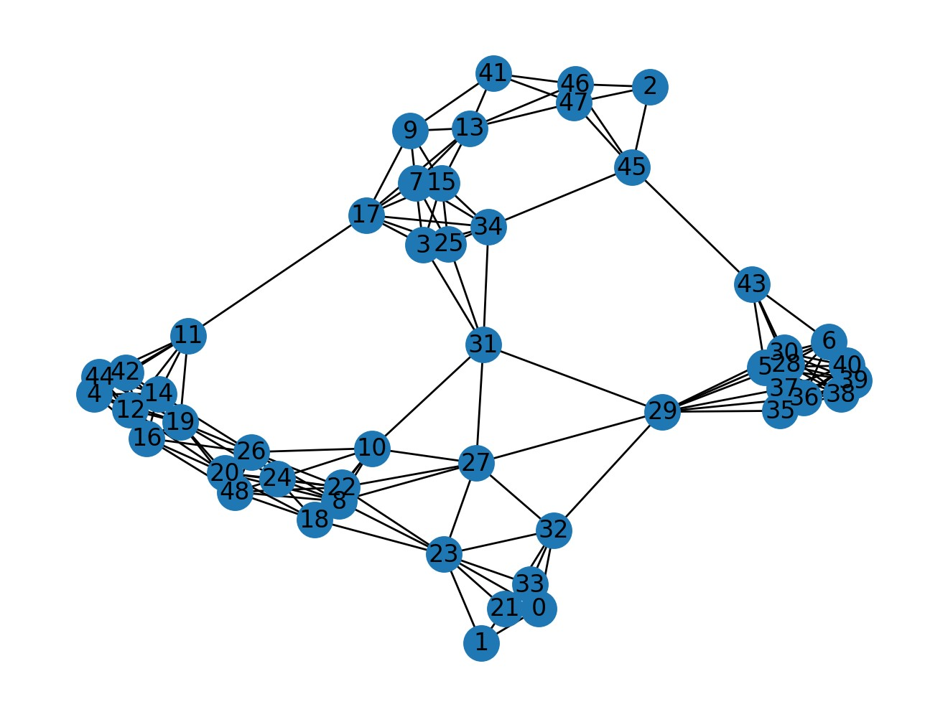

b) here we want to trace the packets like other scenarios for each of the destinations:

in 1.log have received from node 33:

(main) 33 1 7 1 32.2

In 6.log we have:

(main) 33 1 7 6 38.4

In 7.log we have:

(main) 33 1 7 7 63.21

In 19.log we have:

(main) 33 1 7 19 32.2

So we have a route between them.

And here we have a multi-destination packet generated in the 33.log node:

(generate) 33 7 [1, 6, 7, 19] 1

Here we have a general idea of what we did for packet tracing for only one destination in the first scenario. We recursively follow up on each log file and find the packet origin hop by hop. After that by backtracking the route, we successfully have the route of each packet taken from source to destination. A symbolic visual for one of them is like the figure below:

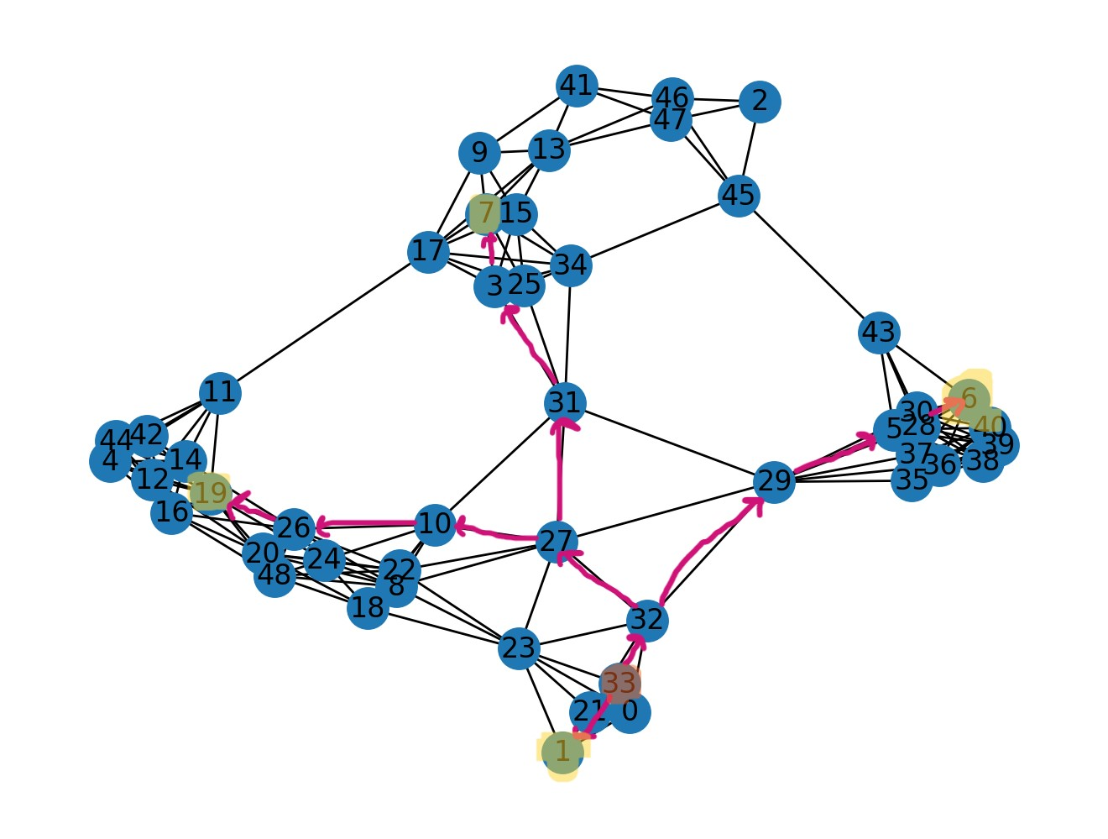

c) here are some of the parameters for this multi-destination network:

distance nodes numbers: [1, 6, 19, 7]

As it is clear, we have several plots for each of the different destinations which are calculated by the network_detail.log file.

nodes PDR [13.793103448275861, 10.344827586206897, 100.0, 100.0, 100.0, 100.0, 96.55172413793103, 10.344827586206897, 100.0, 10.344827586206897, 100.0, 82.75862068965517, 100.0, 100.0, 96.55172413793103, 93.10344827586206, 100.0, 10.344827586206897, 86.20689655172413, 75.86206896551724, 10.344827586206897, 6.896551724137931, 6.896551724137931, 20.689655172413794, 100.0, 44.827586206896555, 10.344827586206897, 48.275862068965516, 10.344827586206897, 93.10344827586206, 0, 10.344827586206897, 13.793103448275861, 100.0, 20.689655172413794, 24.137931034482758, 20.689655172413794, 62.06896551724138, 68.96551724137932, 93.10344827586206, 100.0, 96.55172413793103, 82.75862068965517, 86.20689655172413, 100.0, 100.0, 100.0, 100.0]

average PDR in the whole network [65.58908045977012, 63.218390804597696, 70.83333333333333, 62.85919540229886]

average latency in each node for all destinations [21.36068965517236, 20.986818181817913, 11.75379310344821, 203.79999999999995, 50.046249999999944, 1.2120689655174641, 71.92900000000013, 67.20800000000017, 38.0476, 97.41000000000008, 30.023999999999777, 66.54125, 13.07999999999964, 117.35333333333331, 61.068571428571474, 262.25333333333333, 82.50117647058838, 169.11666666666665, 200.38333333333335, 50.88647058823523, 15.692499999999862, 14.835000000000138, 62.62166666666661, 103.14000000000017, 93.80333333333344, 102.14333333333327, 35.47571428571422, 4.203214285714149, 17.181034482758808, 1.3572413793104667, 18.011785714285526, 24.49172413793108, 26.326428571428835, 22.359310344827637, 1.9093103448275668, 0.5396551724140001, 1.4192857142858446, 0.5792857142853336, 0.8872413793101416, 24.29269230769239, 19.62444444444428, 0.5627586206895746, 72.49333333333324, 5.17703703703691, 10.677083333333172, 22.970999999999446, 45.656923076922844, 0.5234482758617811, 249.77999999999975, 215.33666666666673, 27.07879999999971, 29.790400000000126, 47.9125000000001, 253.8233333333334, 8.026785714285674, 266.27, 19.838518518518548, 24.4827272727273, 17.864285714285643, 173.59333333333325, 61.1326923076923, 252.9433333333333, 53.05413793103451, 223.60333333333338, 22.686551724137995, 29.008888888888695, 23.891481481481176, 0.5631034482757262, 7.081923076923151, 2.104137931034388, 29.627586206896655, 216.66666666666674, 10.778965517241291, 13.124137931034495, 90.97550000000012, 54.86482758620674, 23.562857142857485, 5.212068965517088, 4.068518518518683, 357.5300000000002, 62.79560000000034, 13.155652173912802, 30.885714285714638, 42.074999999999896, 27.64125000000027, 26.24631578947353, 237.56000000000003, 34.01679999999993, 33.70349999999977, 20.740740740740673, 152.81999999999994, 189.95000000000027, 162.96999999999994, 17.521153846153922, 15.591111111110793, 25.32296296296275, 27.60199999999986, 55.45368421052668, 1.7910344827586617, 66.26571428571427, 38.816666666666755, 81.41799999999985, 3.1492857142855866, 23.980000000000153, 4.171785714285371, 0.6044827586207985, 0.6017241379310753, 10.568571428571163, 3.1844827586207494, 46.72750000000053, 3.625172413792911, 12.74034482758588, 19.859310344827612, 0, 6.407931034482497, 15.977599999999892, 2.236206896552011, 8.440344827586104, 2.7600000000003515, 48.94666666666684, 2.029999999999863, 13.568846153846092, 123.94666666666664, 140.95333333333346, 63.179999999999964, 0, 13.47791666666698, 17.465, 94.08772727272729, 91.6257142857144, 58.06999999999984, 73.92999999999984, 61.78428571428559, 93.10799999999972, 54.71700000000019, 78.34304347826091, 1.6949999999999363, 110.39899999999955, 0.5699999999998423, 57.12090909090912, 72.0485714285712, 19.024074074073866, 0.5572413793104496, 115.2399999999999, 202.31333333333328, 11.109655172413763, 1.232068965517297, 30.81103448275854, 29.313103448276102, 6.351428571428561, 0, 135.43666666666672, 1.9824137931035035, 71.78666666666663, 17.100689655172282, 79.4558333333331, 0.5651724137930598, 29.155172413793103, 1.5392857142857028, 27.55592592592595, 1.7896551724137022, 152.3800000000001, 40.177599999999984, 69.0377272727272, 246.57333333333318, 141.80999999999995, 80.05999999999995, 128.68166666666613, 1.991379310345298, 103.98538461538466, 104.06666666666668, 42.85785714285748, 95.5933333333334, 26.11407407407396, 0, 183.33000000000007, 155.4174999999998, 1.20827586206898, 98.3483333333334, 86.30142857142839, 83.08666666666652, 19.761666666666834, 25.093999999999824, 20.02037037037032, 11.134482758620614, 16.120357142857163, 64.33999999999993, 18.654399999999622, 11.8579310344831, 4.5468965517243145, 5.396896551723996, 16.59000000000003]

average burst packet loss in each node for all destinations [[0, 0.3181818181818182, 0, 0, 0.8125, 0, 0, 1.7, 1.2, 0.12, 0, 0.12, 0.625, 0.11538461538461539, 0, 0.3333333333333333, 0, 0.6470588235294118, 0, 0, 0.7058823529411765, 0.20833333333333334, 0.5, 0.16666666666666666, 0, 0, 0, 0.38095238095238093, 0, 0, 0, 0, 0.03571428571428571, 0, 0.03571428571428571, 0, 0, 0, 0.03571428571428571, 0.03571428571428571, 0, 0.11538461538461539, 0.6111111111111112, 0, 1.4166666666666667, 0.037037037037037035, 0.20833333333333334, 0.3, 1.0769230769230769, 0, 0, 0, 0, 0.16, 0.16, 1.25, 0, 0.03571428571428571, 0, 0.07407407407407407, 0.22727272727272727, 0.03571428571428571, 0, 0.11538461538461539, 0, 0, 0, 0, 0.07407407407407407, 0.07407407407407407, 0, 0.11538461538461539, 0, 0, 0, 0, 0, 0.25, 0, 0.38095238095238093, 0, 0, 0.037037037037037035, 0, 0.16, 0.21739130434782608, 0.38095238095238093, 1.3333333333333333, 0.5625, 0.47368421052631576, 0, 0.16, 0.4, 0.07407407407407407, 0, 0, 0, 0.11538461538461539, 0.07407407407407407, 0.07407407407407407, 0.16, 0.5263157894736842, 0, 0, 0.16666666666666666, 0.16, 0.03571428571428571, 0, 0.03571428571428571, 0, 0, 0.03571428571428571, 0, 0.3, 0, 0, 0, 0, 0, 0.16, 0, 0, 0, 0.38095238095238093, 0, 0.11538461538461539, 0, 0, 0.14285714285714285, 0, 0.20833333333333334, 0.03571428571428571, 0.3181818181818182, 0, 0, 0, 1.0, 0, 0.4, 0.2608695652173913, 0.03571428571428571, 1.8, 0, 1.5454545454545454, 2.142857142857143, 0.07407407407407407, 0, 0, 0, 0, 0, 0, 0, 0.03571428571428571, 0, 0, 0, 0, 0, 0.20833333333333334, 0, 0, 0.03571428571428571, 0.07407407407407407, 0, 0, 0.16, 0.3181818181818182, 0, 0, 0, 2.6666666666666665, 0, 1.2307692307692308, 0, 1.0, 0, 0.07407407407407407, 0, 0, 0, 0, 0, 0, 0, 0.5555555555555556, 0.35, 0.07407407407407407, 0, 0.03571428571428571, 0.16666666666666666, 0.16, 0, 0, 0, 0], [0, 0.3181818181818182, 0, 0, 0.8125, 0, 0, 1.7, 1.2, 0.12, 0, 0.12, 0.625, 0.11538461538461539, 0, 0.3333333333333333, 0, 0.6470588235294118, 0, 0, 0.7058823529411765, 0.20833333333333334, 0.5, 0.16666666666666666, 0, 0, 0, 0.38095238095238093, 0, 0, 0, 0, 0.03571428571428571, 0, 0.03571428571428571, 0, 0, 0, 0.03571428571428571, 0.03571428571428571, 0, 0.11538461538461539, 0.6111111111111112, 0, 1.4166666666666667, 0.037037037037037035, 0.20833333333333334, 0.3, 1.0769230769230769, 0, 0, 0, 0, 0.16, 0.16, 1.25, 0, 0.03571428571428571, 0, 0.07407407407407407, 0.22727272727272727, 0.03571428571428571, 0, 0.11538461538461539, 0, 0, 0, 0, 0.07407407407407407, 0.07407407407407407, 0, 0.11538461538461539, 0, 0, 0, 0, 0, 0.25, 0, 0.38095238095238093, 0, 0, 0.037037037037037035, 0, 0.16, 0.21739130434782608, 0.38095238095238093, 1.3333333333333333, 0.5625, 0.47368421052631576, 0, 0.16, 0.4, 0.07407407407407407, 0, 0, 0, 0.11538461538461539, 0.07407407407407407, 0.07407407407407407, 0.16, 0.5263157894736842, 0, 0, 0.16666666666666666, 0.16, 0.03571428571428571, 0, 0.03571428571428571, 0, 0, 0.03571428571428571, 0, 0.3, 0, 0, 0, 0, 0, 0.16, 0, 0, 0, 0.38095238095238093, 0, 0.11538461538461539, 0, 0, 0.14285714285714285, 0, 0.20833333333333334, 0.03571428571428571, 0.3181818181818182, 0, 0, 0, 1.0, 0, 0.4, 0.2608695652173913, 0.03571428571428571, 1.8, 0, 1.5454545454545454, 2.142857142857143, 0.07407407407407407, 0, 0, 0, 0, 0, 0, 0, 0.03571428571428571, 0, 0, 0, 0, 0, 0.20833333333333334, 0, 0, 0.03571428571428571, 0.07407407407407407, 0, 0, 0.16, 0.3181818181818182, 0, 0, 0, 2.6666666666666665, 0, 1.2307692307692308, 0, 1.0, 0, 0.07407407407407407, 0, 0, 0, 0, 0, 0, 0, 0.5555555555555556, 0.35, 0.07407407407407407, 0, 0.03571428571428571, 0.16666666666666666, 0.16, 0, 0, 0, 0], [0, 0.3181818181818182, 0, 0, 0.8125, 0, 0, 1.7, 1.2, 0.12, 0, 0.12, 0.625, 0.11538461538461539, 0, 0.3333333333333333, 0, 0.6470588235294118, 0, 0, 0.7058823529411765, 0.20833333333333334, 0.5, 0.16666666666666666, 0, 0, 0, 0.38095238095238093, 0, 0, 0, 0, 0.03571428571428571, 0, 0.03571428571428571, 0, 0, 0, 0.03571428571428571, 0.03571428571428571, 0, 0.11538461538461539, 0.6111111111111112, 0, 1.4166666666666667, 0.037037037037037035, 0.20833333333333334, 0.3, 1.0769230769230769, 0, 0, 0, 0, 0.16, 0.16, 1.25, 0, 0.03571428571428571, 0, 0.07407407407407407, 0.22727272727272727, 0.03571428571428571, 0, 0.11538461538461539, 0, 0, 0, 0, 0.07407407407407407, 0.07407407407407407, 0, 0.11538461538461539, 0, 0, 0, 0, 0, 0.25, 0, 0.38095238095238093, 0, 0, 0.037037037037037035, 0, 0.16, 0.21739130434782608, 0.38095238095238093, 1.3333333333333333, 0.5625, 0.47368421052631576, 0, 0.16, 0.4, 0.07407407407407407, 0, 0, 0, 0.11538461538461539, 0.07407407407407407, 0.07407407407407407, 0.16, 0.5263157894736842, 0, 0, 0.16666666666666666, 0.16, 0.03571428571428571, 0, 0.03571428571428571, 0, 0, 0.03571428571428571, 0, 0.3, 0, 0, 0, 0, 0, 0.16, 0, 0, 0, 0.38095238095238093, 0, 0.11538461538461539, 0, 0, 0.14285714285714285, 0, 0.20833333333333334, 0.03571428571428571, 0.3181818181818182, 0, 0, 0, 1.0, 0, 0.4, 0.2608695652173913, 0.03571428571428571, 1.8, 0, 1.5454545454545454, 2.142857142857143, 0.07407407407407407, 0, 0, 0, 0, 0, 0, 0, 0.03571428571428571, 0, 0, 0, 0, 0, 0.20833333333333334, 0, 0, 0.03571428571428571, 0.07407407407407407, 0, 0, 0.16, 0.3181818181818182, 0, 0, 0, 2.6666666666666665, 0, 1.2307692307692308, 0, 1.0, 0, 0.07407407407407407, 0, 0, 0, 0, 0, 0, 0, 0.5555555555555556, 0.35, 0.07407407407407407, 0, 0.03571428571428571, 0.16666666666666666, 0.16, 0, 0, 0, 0], [0, 0.3181818181818182, 0, 0, 0.8125, 0, 0, 1.7, 1.2, 0.12, 0, 0.12, 0.625, 0.11538461538461539, 0, 0.3333333333333333, 0, 0.6470588235294118, 0, 0, 0.7058823529411765, 0.20833333333333334, 0.5, 0.16666666666666666, 0, 0, 0, 0.38095238095238093, 0, 0, 0, 0, 0.03571428571428571, 0, 0.03571428571428571, 0, 0, 0, 0.03571428571428571, 0.03571428571428571, 0, 0.11538461538461539, 0.6111111111111112, 0, 1.4166666666666667, 0.037037037037037035, 0.20833333333333334, 0.3, 1.0769230769230769, 0, 0, 0, 0, 0.16, 0.16, 1.25, 0, 0.03571428571428571, 0, 0.07407407407407407, 0.22727272727272727, 0.03571428571428571, 0, 0.11538461538461539, 0, 0, 0, 0, 0.07407407407407407, 0.07407407407407407, 0, 0.11538461538461539, 0, 0, 0, 0, 0, 0.25, 0, 0.38095238095238093, 0, 0, 0.037037037037037035, 0, 0.16, 0.21739130434782608, 0.38095238095238093, 1.3333333333333333, 0.5625, 0.47368421052631576, 0, 0.16, 0.4, 0.07407407407407407, 0, 0, 0, 0.11538461538461539, 0.07407407407407407, 0.07407407407407407, 0.16, 0.5263157894736842, 0, 0, 0.16666666666666666, 0.16, 0.03571428571428571, 0, 0.03571428571428571, 0, 0, 0.03571428571428571, 0, 0.3, 0, 0, 0, 0, 0, 0.16, 0, 0, 0, 0.38095238095238093, 0, 0.11538461538461539, 0, 0, 0.14285714285714285, 0, 0.20833333333333334, 0.03571428571428571, 0.3181818181818182, 0, 0, 0, 1.0, 0, 0.4, 0.2608695652173913, 0.03571428571428571, 1.8, 0, 1.5454545454545454, 2.142857142857143, 0.07407407407407407, 0, 0, 0, 0, 0, 0, 0, 0.03571428571428571, 0, 0, 0, 0, 0, 0.20833333333333334, 0, 0, 0.03571428571428571, 0.07407407407407407, 0, 0, 0.16, 0.3181818181818182, 0, 0, 0, 2.6666666666666665, 0, 1.2307692307692308, 0, 1.0, 0, 0.07407407407407407, 0, 0, 0, 0, 0, 0, 0, 0.5555555555555556, 0.35, 0.07407407407407407, 0, 0.03571428571428571, 0.16666666666666666, 0.16, 0, 0, 0, 0]]

scanning energy in each node [1208.674500002935, 1218.2238000029697, 1215.0462600029584, 1210.9596600029433, 1216.1971800029626, 1209.3750600029377, 1216.322280002963, 1211.143140002944, 1201.9441200029105, 1213.9203600029543, 1202.311080002912, 1208.7579000029355, 1211.1264600029442, 1211.6685600029462, 1211.3349600029449, 1210.4592600029416, 1214.3373600029556, 1209.5919000029385, 1211.3016000029447, 1209.4000800029378, 1209.95886000294, 1208.5577400029347, 1203.0366600029145, 1205.088300002922, 1208.582760002935, 1211.943780002947, 1209.6002400029386, 1200.985020002907, 1207.9989600029328, 1201.6522200029096, 1209.4251000029378, 1250.1910200030861, 1204.2793200029191, 1209.6002400029386, 1205.5136400029235, 1213.6701600029535, 1211.0097000029436, 1210.8095400029429, 1219.875120002976, 1219.958520002976, 1218.6074400029713, 1219.0494600029726, 1216.1554800029623, 1209.199920002937, 1215.6550800029604, 1207.4735400029306, 1212.9529200029506, 1212.1606200029478, 1209.5251800029382]

switching energy in each node [2.69119800000007, 2.1048660000000483, 2.262978000000054, 2.526498000000064, 2.253096000000054, 2.7109620000000714, 2.1905100000000517, 2.5660260000000656, 3.1325940000000263, 2.4013260000000596, 3.0897720000000333, 2.67802200000007, 2.539674000000065, 2.526498000000064, 2.572614000000066, 2.572614000000066, 2.3552100000000578, 2.661552000000069, 2.5363800000000647, 2.67143400000007, 2.6648460000000695, 2.6879040000000707, 3.1128300000000295, 2.9876580000000486, 2.6944920000000705, 2.516616000000064, 2.67472800000007, 3.208356000000015, 2.7274320000000722, 3.162240000000022, 2.707668000000071, 0.023057999999999995, 2.990952000000048, 2.67472800000007, 2.8888380000000633, 2.4013260000000596, 2.523204000000064, 2.549556000000065, 1.9731060000000433, 1.9731060000000433, 2.0851020000000475, 2.015928000000045, 2.253096000000054, 2.697786000000071, 2.2695660000000544, 2.813076000000075, 2.4507360000000613, 2.467206000000062, 2.654964000000069]

transmitting energy in each node [18.888386399998957, 14.773168799999317, 15.88289039999922, 17.732426399999056, 15.813532799999226, 19.027101599998947, 15.374267999999265, 18.009856799999035, 21.986359199998688, 16.853896799999138, 21.685809599998716, 18.795909599998964, 17.824903199999053, 17.732426399999056, 18.05609519999903, 18.05609519999903, 16.530227999999163, 18.680313599998975, 17.801783999999053, 18.74967119999897, 18.703432799998975, 18.86526719999896, 21.847643999998702, 20.96911439999878, 18.911505599998957, 17.663068799999067, 18.772790399998968, 22.518100799998642, 19.142697599998936, 22.194431999998674, 19.00398239999895, 0.16183440000000002, 20.992233599998777, 18.772790399998968, 20.275538399998837, 16.853896799999138, 17.70930719999906, 17.894260799999046, 13.848400799999398, 13.848400799999398, 14.634453599999327, 14.14895039999937, 15.813532799999226, 18.934624799998954, 15.929128799999216, 19.743796799998883, 17.200684799999102, 17.316280799999095, 18.634075199998982]

sleeping energy in each node [0.0, 0.0, 0.0, 0.0, 0.0, 0.0, 0.0, 0.0, 0.0, 0.0, 0.0, 0.0, 0.0, 0.0, 0.0, 0.0, 0.0, 0.0, 0.0, 0.0, 0.0, 0.0, 0.0, 0.0, 0.0, 0.0, 0.0, 0.0, 0.0, 0.0, 0.0, 0.0, 0.0, 0.0, 0.0, 0.0, 0.0, 0.0, 0.0, 0.0, 0.0, 0.0, 0.0, 0.0, 0.0, 0.0, 0.0, 0.0, 0.0]

total energy in each node [1230.254084402934, 1235.101834802969, 1233.1921284029577, 1231.2185844029425, 1234.2638088029619, 1231.1131236029369, 1233.8870580029625, 1231.7190228029428, 1227.0630732029092, 1233.1755828029536, 1227.0866616029107, 1230.2318316029346, 1231.4910372029433, 1231.9274844029453, 1231.963669202944, 1231.0879692029407, 1233.222798002955, 1230.9337656029375, 1231.6397640029438, 1230.821185202937, 1231.327138802939, 1230.1109112029337, 1227.9971340029133, 1229.0450724029208, 1230.188757602934, 1232.1234648029463, 1231.0477584029375, 1226.7114768029057, 1229.8690896029318, 1227.0088920029084, 1231.1367504029367, 1250.3759124030862, 1228.262505602918, 1231.0477584029375, 1228.6780164029224, 1232.9253828029528, 1231.2422112029428, 1231.253356802942, 1235.6966268029755, 1235.7800268029755, 1235.3269956029706, 1235.214338402972, 1234.2221088029617, 1230.8323308029362, 1233.8537748029598, 1230.0304128029295, 1232.6043408029498, 1231.9441068029469, 1230.8142192029372]

All of the modified codes are available in the My_performance_analyzer.py file in the current directory. And note that we need to don’t consider redundancies for box plot charts.